Java Collections Framework
[Reference: java.sun.com]

Introduction
- A collection — sometimes called a container — is simply an object that groups multiple elements into a single unit.
- Collections are used to store, retrieve, manipulate, and communicate aggregate data.
- Collection implementations in earlier (pre-1.2) versions of the Java platform included Vector, Hashtable, and array. However, those earlier versions did not contain a collections framework.
What Is a Collections Framework?
A collections framework is a unified architecture for representing and manipulating collections. All collections frameworks contain the following:
- Interfaces: These are abstract data types that represent collections. Interfaces allow collections to be manipulated independently of the details of their representation. In object-oriented languages, interfaces generally form a hierarchy.
- Implementations: These are the concrete implementations of the collection interfaces. In essence, they are reusable data structures.
- Algorithms: These are the methods that perform useful computations, such as searching and sorting, on objects that implement collection interfaces. The algorithms are said to be polymorphic: that is, the same method can be used on many different implementations of the appropriate collection interface. In essence, algorithms are reusable functionality.
Benefits of the Java Collections Framework:
- Reduces programming effort: By providing useful data structures and algorithms, the Collections Framework frees you to concentrate on the important parts of your program rather than on the low-level "plumbing" required to make it work. By facilitating interoperability among unrelated APIs, the Java Collections Framework frees you from writing adapter objects or conversion code to connect APIs.
- Increases program speed and quality: This Collections Framework provides high-performance, high-quality implementations of useful data structures and algorithms. The various implementations of each interface are interchangeable, so programs can be easily tuned by switching collection implementations. Because you're freed from the drudgery of writing your own data structures, you'll have more time to devote to improving programs' quality and performance.
- Allows interoperability among unrelated APIs: The collection interfaces are the vernacular by which APIs pass collections back and forth. If my network administration API furnishes a collection of node names and if your GUI toolkit expects a collection of column headings, our APIs will interoperate seamlessly, even though they were written independently.
- Reduces effort to learn and to use new APIs: Many APIs naturally take collections on input and furnish them as output. In the past, each such API had a small sub-API devoted to manipulating its collections. There was little consistency among these ad hoc collections sub-APIs, so you had to learn each one from scratch, and it was easy to make mistakes when using them. With the advent of standard collection interfaces, the problem went away.
- Reduces effort to design new APIs: This is the flip side of the previous advantage. Designers and implementers don't have to reinvent the wheel each time they create an API that relies on collections; instead, they can use standard collection interfaces.
- Fosters software reuse: New data structures that conform to the standard collection interfaces are by nature reusable. The same goes for new algorithms that operate on objects that implement these interfaces.

Interfaces
The core collection interfaces encapsulate different types of collections, which are shown in the figure below. These interfaces allow collections to be manipulated independently of the details of their representation.
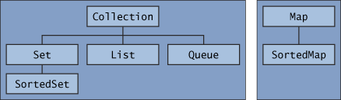
- Note that all the core collection interfaces are generic. For example, this is the declaration of the Collection interface.
public interface Collection<E>...
- A Set is a special kind of Collection, a SortedSet is a special kind of Set, and so forth. Note also that the hierarchy consists of two distinct trees — a Map is not a true Collection.
- If an unsupported operation is invoked, a collection throws an UnsupportedOperationException.

The following list describes the core collection interfaces:
- Collection — the root of the collection hierarchy. A collection represents a group of objects known as its elements. The Collection interface is the least common denominator that all collections implement and is used to pass collections around and to manipulate them when maximum generality is desired. Some types of collections allow duplicate elements, and others do not. Some are ordered and others are unordered. The Java platform doesn't provide any direct implementations of this interface but provides implementations of more specific subinterfaces, such as Set and List.
- Set — a collection that cannot contain duplicate elements. This interface models the mathematical set abstraction and is used to represent sets, such as the cards comprising a poker hand, the courses making up a student's schedule, or the processes running on a machine.
- List — an ordered collection (sometimes called a sequence). Lists can contain duplicate elements. The user of a List generally has precise control over where in the list each element is inserted and can access elements by their integer index (position).
- Queue — a collection used to hold multiple elements prior to processing. Besides basic Collection operations, a Queue provides additional insertion, extraction, and inspection operations.
Queues typically, but do not necessarily, order elements in a FIFO (first-in, first-out) manner. Among the exceptions are priority queues, which order elements according to a supplied comparator or the elements' natural ordering. Whatever the ordering used, the head of the queue is the element that would be removed by a call to remove or poll. In a FIFO queue, all new elements are inserted at the tail of the queue. Other kinds of queues may use different placement rules. Every Queue implementation must specify its ordering properties.
- Map — an object that maps keys to values. A Map cannot contain duplicate keys; each key can map to at most one value.
The last two core collection interfaces are merely sorted versions of Set and Map:
- SortedSet — a Set that maintains its elements in ascending order. Several additional operations are provided to take advantage of the ordering. Sorted sets are used for naturally ordered sets, such as word lists and membership rolls.
- SortedMap — a Map that maintains its mappings in ascending key order. This is the Map analog of SortedSet. Sorted maps are used for naturally ordered collections of key/value pairs, such as dictionaries and telephone directories.
- The Collection Interface
- A Collection represents a group of objects known as its elements.
public interface Collection<E> extends Iterable<E> {
// Basic operations
int size();
boolean isEmpty();
boolean contains(Object element);
boolean add(E element); //optional
boolean remove(Object element); //optional
Iterator<E> iterator();

// Bulk operations
boolean containsAll(Collection<?> c);
boolean addAll(Collection<? extends E> c); //optional
boolean removeAll(Collection<?> c); //optional
boolean retainAll(Collection<?> c); //optional
void clear(); //optional

// Array operations
Object[] toArray();
<T> T[] toArray(T[] a);
}
- Traversing Collections:
There are two ways to traverse collections: (a) with the for-each construct and (b) by using Iterators.

for-each Construct
The for-each construct allows you to concisely traverse a collection or array using a for loop — see The for Statement. The following code uses the for-each construct to print out each element of a collection on a separate line.

for (Object o : collection)
System.out.println(o);

Iterators
An Iterator is an object that enables you to traverse through a collection and to remove elements from the collection selectively, if desired. You get an Iterator for a collection by calling its iterator method. The following is the Iterator interface.

public interface Iterator<E> {
boolean hasNext();
E next();
void remove(); //optional
}
Use Iterator instead of the for-each construct when you need to:
- Remove the current element. The for-each construct hides the iterator, so you cannot call remove. Therefore, the for-each construct is not usable for filtering.
- Iterate over multiple collections in parallel.
The following method shows you how to use an Iterator to filter an arbitrary Collection — that is, traverse the collection removing specific elements.

static void filter(Collection<?> c) {
for (Iterator<?> it = c.iterator(); it.hasNext(); )
if (!cond(it.next()))
it.remove();
}
- Collection Interface Bulk Operations
Bulk operations perform an operation on an entire Collection. You could implement these shorthand operations using the basic operations, though in most cases such implementations would be less efficient. The following are the bulk operations:
- containsAll — returns true if the target Collection contains all of the elements in the specified Collection.
- addAll — adds all of the elements in the specified Collection to the target Collection.
- removeAll — removes from the target Collection all of its elements that are also contained in the specified Collection.
- retainAll — removes from the target Collection all its elements that are not also contained in the specified Collection. That is, it retains only those elements in the target Collection that are also contained in the specified Collection.
- clear — removes all elements from the Collection.
The addAll, removeAll, and retainAll methods all return true if the target Collection was modified in the process of executing the operation.
As a simple example of the power of bulk operations, consider the following idiom to remove all instances of a specified element, e, from a Collection, c.
c.removeAll(Collections.singleton(e));

More specifically, suppose you want to remove all of the null elements from a Collection.

c.removeAll(Collections.singleton(null));

This idiom uses Collections.singleton, which is a static factory method that returns an immutable Set containing only the specified element.
- Collection Interface Array Operations
The toArray methods are provided as a bridge between collections and older APIs that expect arrays on input. The array operations allow the contents of a Collection to be translated into an array. The simple form with no arguments creates a new array of Object. The more complex form allows the caller to provide an array or to choose the runtime type of the output array.
For example, suppose that c is a Collection. The following snippet dumps the contents of c into a newly allocated array of Object whose length is identical to the number of elements in c.
Object[] a = c.toArray();

Suppose that c is known to contain only strings (perhaps because c is of type Collection<String>). The following snippet dumps the contents of c into a newly allocated array of String whose length is identical to the number of elements in c.

String[] a = c.toArray(new String[0]);

- The Set Interface

- A Set is a Collection that cannot contain duplicate elements.
- The Set interface contains only methods inherited from Collection and adds the restriction that duplicate elements are prohibited.
- Set also adds a stronger contract on the behavior of the equals and hashCode operations, allowing Set instances to be compared meaningfully even if their implementation types differ.
- Two Set instances are equal if they contain the same elements.

public interface Set<E> extends Collection<E> {
// Basic operations
int size();
boolean isEmpty();
boolean contains(Object element);
boolean add(E element); //optional
boolean remove(Object element); //optional
Iterator<E> iterator();

// Bulk operations
boolean containsAll(Collection<?> c);
boolean addAll(Collection<? extends E> c); //optional
boolean removeAll(Collection<?> c); //optional
boolean retainAll(Collection<?> c); //optional
void clear(); //optional

// Array Operations
Object[] toArray();
<T> T[] toArray(T[] a);
}
- Set implementations: HashSet, TreeSet, and LinkedHashSet
  - HashSet, which stores its elements in a hash table, is the best-performing implementation; however it makes no guarantees concerning the order of iteration.
  - TreeSet, which stores its elements in a red-black tree, orders its elements based on their values; it is substantially slower than HashSet.
  - LinkedHashSet, which is implemented as a hash table with a linked list running through it, orders its elements based on the order in which they were inserted into the set

Set Interface Basic Operations
- The size operation returns the number of elements in the Set (its cardinality).
- The isEmpty method does exactly what you think it would.
- The add method adds the specified element to the Set if it's not already present and returns a boolean indicating whether the element was added.
- The remove method removes the specified element from the Set if it's present and returns a boolean indicating whether the element was present.
- The iterator method returns an Iterator over the Set.

Sample code:
import java.util.*;

public class FindDups {
public static void main(String[] args) {
Set<String> s = new HashSet<String>();
for (String a : args)
if (!s.add(a))
System.out.println("Duplicate detected: " + a);

System.out.println(s.size() + " distinct words: " + s);
}
}
Note: Note that the code always refers to the Collection by its interface type (Set) rather than by its implementation type (HashSet). This is a strongly recommended programming practice because it gives you the flexibility to change implementations merely by changing the constructor.

Set Interface Bulk Operations
Bulk operations are particularly well suited to Sets; when applied, they perform standard set-algebraic operations. Suppose s1 and s2 are sets. Here's what bulk operations do:
- s1.containsAll(s2) — returns true if s2 is a subset of s1. (s2 is a subset of s1 if set s1 contains all of the elements in s2.)
- s1.addAll(s2) — transforms s1 into the union of s1 and s2. (The union of two sets is the set containing all of the elements contained in either set.)
- s1.retainAll(s2) — transforms s1 into the intersection of s1 and s2. (The intersection of two sets is the set containing only the elements common to both sets.)
- s1.removeAll(s2) — transforms s1 into the (asymmetric) set difference of s1 and s2. (For example, the set difference of s1 minus s2 is the set containing all of the elements found in s1 but not in s2.)

Set Interface Array Operations
The array operations don't do anything special for Sets beyond what they do for any other Collection.

- The List Interface
- A List is an ordered Collection (sometimes called a sequence).
- Lists may contain duplicate elements.
- In addition to the operations inherited from Collection, the List interface includes operations for the following:
- Positional access — manipulates elements based on their numerical position in the list
- Search — searches for a specified object in the list and returns its numerical position
- Iteration — extends Iterator semantics to take advantage of the list's sequential nature
- Range-view — performs arbitrary range operations on the list.
public interface List<E> extends Collection<E> {
// Positional access
E get(int index);
E set(int index, E element); //optional
boolean add(E element); //optional
void add(int index, E element); //optional
E remove(int index); //optional
boolean addAll(int index,
Collection<? extends E> c); //optional

// Search
int indexOf(Object o);
int lastIndexOf(Object o);

// Iteration
ListIterator<E> listIterator();
ListIterator<E> listIterator(int index);

// Range-view
List<E> subList(int from, int to);
}

List implementations: ArrayList, LinkedList and Vector
- ArrayList, which is usually the better-performing implementation.
- LinkedList, which offers better performance under certain circumstances.
- Also, Vector has been retrofitted to implement List.
Comparison to Vector
- Of course, List is an interface, while Vector is a concrete implementation.) List fixes several minor API deficiencies in Vector. Commonly used Vector operations, such as elementAt and setElementAt, have been given much shorter names.
- Unlike the ArrayList class, the Vector class is thread-safe, meaning that concurrent calls to the vector will not compromise its integrity.
- The Queue Interface
- A Queue is a collection for holding elements prior to processing.
- Besides basic Collection operations, queues provide additional insertion, removal, and inspection operations.
public interface Queue<E> extends Collection<E> {
E element();
boolean offer(E e);
E peek();
E poll();
E remove();
}
- Each Queue method exists in two forms:
(1) one throws an exception if the operation fails, and
(2) the other returns a special value if the operation fails (either null or false, depending on the operation).
- The regular structure of the interface is illustrated in the following table.
Queue Interface Structure
 | Throws exception | Returns special value
Insert | add(e) | offer(e)
Remove | remove() | poll()
Examine | element() | peek()

- Queues typically, but not necessarily, order elements in a FIFO (first-in-first-out) manner. Among the exceptions are priority queues, which order elements according to their values).
- Whatever ordering is used, the head of the queue is the element that would be removed by a call to remove or poll.
- In a FIFO queue, all new elements are inserted at the tail of the queue. Other kinds of queues may use different placement rules.
- Every Queue implementation must specify its ordering properties.
- It is possible for a Queue implementation to restrict the number of elements that it holds; such queues are known as bounded. Some Queue implementations in java.util.concurrent are bounded, but the implementations in java.util are not.
- The add method, which Queue inherits from Collection, inserts an element unless it would violate the queue's capacity restrictions, in which case it throws IllegalStateException. The offer method, which is intended solely for use on bounded queues, differs from add only in that it indicates failure to insert an element by returning false.
- The remove and poll methods both remove and return the head of the queue. Exactly which element gets removed is a function of the queue's ordering policy. The remove and poll methods differ in their behavior only when the queue is empty. Under these circumstances, remove throws NoSuchElementException, while poll returns null.
- The element and peek methods return, but do not remove, the head of the queue. They differ from one another in precisely the same fashion as remove and poll: If the queue is empty, element throws NoSuchElementException, while peek returns null.
- Queue implementations generally do not allow insertion of null elements. The LinkedList implementation, which was retrofitted to implement Queue, is an exception. For historical reasons, it permits null elements, but you should refrain from taking advantage of this, because null is used as a special return value by the poll and peek methods.
# In the following example program, a queue is used to implement a countdown timer. The queue is preloaded with all the integer values from a number specified on the command line to zero, in descending order. Then, the values are removed from the queue and printed at one-second intervals. The program is artificial in that it would be more natural to do the same thing without using a queue, but it illustrates the use of a queue to store elements prior to subsequent processing.
import java.util.*;

public class Countdown {
public static void main(String[] args)
throws InterruptedException {
int time = Integer.parseInt(args[0]);
Queue<Integer> queue = new LinkedList<Integer>();
for (int i = time; i >= 0; i--)
queue.add(i);
while (!queue.isEmpty()) {
System.out.println(queue.remove());
Thread.sleep(1000);
}
}
}
# In the following example, a priority queue is used to sort a collection of elements. Again this program is artificial in that there is no reason to use it in favor of the sort method provided in Collections, but it illustrates the behavior of priority queues.
static <E> List<E> heapSort(Collection<E> c) {
Queue<E> queue = new PriorityQueue<E>(c);
List<E> result = new ArrayList<E>();
while (!queue.isEmpty())
result.add(queue.remove());
return result;
}
- The Map Interface
- A Map is an object that maps keys to values.
- A map cannot contain duplicate keys: Each key can map to at most one value.

public interface Map<K,V> {

// Basic operations
V put(K key, V value);
V get(Object key);
V remove(Object key);
boolean containsKey(Object key);
boolean containsValue(Object value);
int size();
boolean isEmpty();

// Bulk operations
void putAll(Map<? extends K, ? extends V> m);
void clear();

// Collection Views
public Set<K> keySet();
public Collection<V> values();
public Set<Map.Entry<K,V>> entrySet();

// Interface for entrySet elements
public interface Entry {
K getKey();
V getValue();
V setValue(V value);
}
}
Map implementations: HashMap, TreeMap, and LinkedMap.
- Their behavior and performance are precisely analogous to HashSet, TreeSet, and LinkedHashSet.
- Also, Hashtable was retrofitted to implement Map.

Comparison to Hashtable
- Map is an interface, while Hashtable is a concrete implementation.
The following are the major differences:
- Map provides Collection views instead of direct support for iteration via Enumeration objects. Collection views greatly enhance the expressiveness of the interface.
- Map allows you to iterate over keys, values, or key-value pairs; Hashtable does not provide the third option.
- Map provides a safe way to remove entries in the midst of iteration; Hashtable did not.
Finally, Map fixes a minor deficiency in the Hashtable interface. Hashtable has a method called contains, which returns true if the Hashtable contains a given value. Given its name, you'd expect this method to return true if the Hashtable contained a given key, because the key is the primary access mechanism for a Hashtable. The Map interface eliminates this source of confusion by renaming the method containsValue. Also, this improves the interface's consistency — containsValue parallels containsKey.

Multimaps
A multimap is like a Map but it can map each key to multiple values. The Java Collections Framework doesn't include an interface for multimaps because they aren't used all that commonly.

- The SortedSet Interface
- A SortedSet is a Set that maintains its elements in ascending order, sorted according to the elements' natural ordering or according to a Comparator provided at SortedSet creation time.
- In addition to the normal Set operations, the SortedSet interface provides operations for the following:
  - Range view — allows arbitrary range operations on the sorted set
  - Endpoints — returns the first or last element in the sorted set
  - Comparator access — returns the Comparator, if any, used to sort the set

public interface SortedSet<E> extends Set<E> {
// Range-view
SortedSet<E> subSet(E fromElement, E toElement);
SortedSet<E> headSet(E toElement);
SortedSet<E> tailSet(E fromElement);

// Endpoints
E first();
E last();
// Comparator access
Comparator<? super E> comparator();
}

Set Operations

- The operations that SortedSet inherits from Set behave identically on sorted sets and normal sets with two exceptions:
  - The Iterator returned by the iterator operation traverses the sorted set in order.
  - The array returned by toArray contains the sorted set's elements in order.
- Although the interface doesn't guarantee it, the toString method of the Java platform's SortedSet implementations returns a string containing all the elements of the sorted set, in order.
- The SortedMap Interface
- A SortedMap is a Map that maintains its entries in ascending order, sorted according to the keys' natural ordering, or according to a Comparator provided at the time of the SortedMap creation.
- Natural ordering and Comparators are discussed in the Object Ordering section.
- The SortedMap interface provides operations for normal Map operations and for the following:
  - Range view — performs arbitrary range operations on the sorted map
  - Endpoints — returns the first or the last key in the sorted map
  - Comparator access — returns the Comparator, if any, used to sort the map

public interface SortedMap<K, V> extends Map<K, V>{
Comparator<? super K> comparator();
SortedMap<K, V> subMap(K fromKey, K toKey);
SortedMap<K, V> headMap(K toKey);
SortedMap<K, V> tailMap(K fromKey);
K firstKey();
K lastKey();
}

Map Operations
- The operations SortedMap inherits from Map behave identically on sorted maps and normal maps with two exceptions:
  - The Iterator returned by the iterator operation on any of the sorted map's Collection views traverse the collections in order.
  - The arrays returned by the Collection views' toArray operations contain the keys, values, or entries in order.
- Although it isn't guaranteed by the interface, the toString method of the Collection views in all the Java platform's SortedMap implementations returns a string containing all the elements of the view, in order.

- Object Ordering

- A List l may be sorted as follows.

Collections.sort(l);
- If the List consists of String elements, it will be sorted into alphabetical order.
- If it consists of Date elements, it will be sorted into chronological order.
How does this happen? String and Date both implement the Comparable interface.
- Comparable implementations provide a natural ordering for a class, which allows objects of that class to be sorted automatically.
- The following table summarizes some of the more important Java platform classes that implement Comparable.

Classes Implementing Comparable
Class | Natural Ordering
Byte | Signed numerical
Character | Unsigned numerical
Long | Signed numerical
Integer | Signed numerical
Short | Signed numerical
Double | Signed numerical
Float | Signed numerical
BigInteger | Signed numerical
BigDecimal | Signed numerical
Boolean | Boolean.FALSE < Boolean.TRUE
File | System-dependent lexicographic on path name
String | Lexicographic
Date | Chronological
CollationKey | Locale-specific lexicographic
- If you try to sort a list, the elements of which do not implement Comparable, Collections.sort(list) will throw a ClassCastException.
- Similarly, Collections.sort(list, comparator) will throw a ClassCastException if you try to sort a list whose elements cannot be compared to one another using the comparator.
- Elements that can be compared to one another are called mutually comparable. Although elements of different types may be mutually comparable, none of the classes listed here permit interclass comparison.

Writing Your Own Comparable Types

- The Comparable interface consists of the following method.

public interface Comparable<T> {
public int compareTo(T o);
}
- The compareTo method compares the receiving object with the specified object and returns a negative integer, 0, or a positive integer depending on whether the receiving object is less than, equal to, or greater than the specified object. If the specified object cannot be compared to the receiving object, the method throws a ClassCastException.
import java.util.*;

public class Name implements Comparable<Name> {
private final String firstName, lastName;

public Name(String firstName, String lastName) {
if (firstName == null || lastName == null)
throw new NullPointerException();
this.firstName = firstName;
this.lastName = lastName;
}

public String firstName() { return firstName; }
public String lastName() { return lastName; }

public boolean equals(Object o) {
if (!(o instanceof Name))
return false;
Name n = (Name)o;
return n.firstName.equals(firstName) &&
n.lastName.equals(lastName);
}

public int hashCode() {
return 31*firstName.hashCode() + lastName.hashCode();
}

public String toString() {
return firstName + " " + lastName;
}

public int compareTo(Name n) {
int lastCmp = lastName.compareTo(n.lastName);
return (lastCmp != 0 ? lastCmp :
firstName.compareTo(n.firstName));
}
}

Comparators
- What if you want to sort some objects in an order other than their natural ordering? Or what if you want to sort some objects that don't implement Comparable? To do either of these things, you'll need to provide a Comparator — an object that encapsulates an ordering.
- Like the Comparable interface, the Comparator interface consists of a single method.
public interface Comparator<T> {
int compare(T o1, T o2);
}
- The compare method compares its two arguments, returning a negative integer, 0, or a positive integer depending on whether the first argument is less than, equal to, or greater than the second. If either of the arguments has an inappropriate type for the Comparator, the compare method throws a ClassCastException.
- Much of what was said about Comparable applies to Comparator as well.
- Writing a compare method is nearly identical to writing a compareTo method, except that the former gets both objects passed in as arguments. The compare method has to obey the same four technical restrictions as Comparable's compareTo method for the same reason — a Comparator must induce a total order on the objects it compares.
Suppose you have a class called Employee, as follows.
public class Employee implements Comparable<Employee> {
public Name name() { ... }
public int number() { ... }
public Date hireDate() { ... }
...
}
Let's assume that the natural ordering of Employee instances is Name ordering (as defined in the previous example) on employee name. Unfortunately, the boss has asked for a list of employees in order of seniority. This means we have to do some work, but not much. The following program will produce the required list.
import java.util.*;
public class EmpSort {
static final Comparator<Employee> SENIORITY_ORDER =
new Comparator<Employee>() {
public int compare(Employee e1, Employee e2) {
return e2.hireDate().compareTo(e1.hireDate());
}
};

// Employee database
static final Collection<Employee> employees = ... ;

public static void main(String[] args) {
List<Employee>e = new ArrayList<Employee>(employees);
Collections.sort(e, SENIORITY_ORDER);
System.out.println(e);
}
}
Summary of Interfaces
The Java Collections Framework hierarchy consists of two distinct interface trees:
- The first tree starts with the Collection interface, which provides for the basic functionality used by all collections, such as add and remove methods. Its subinterfaces — Set, List, and Queue — provide for more specialized collections.
The Set interface does not allow duplicate elements. This can be useful for storing collections such as a deck of cards or student records. The Set interface has a subinterface, SortedSet, that provides for ordering of elements in the set.
The List interface provides for an ordered collection, for situations in which you need precise control over where each element is inserted. You can retrieve elements from a List by their exact position.
The Queue interface enables additional insertion, extraction, and inspection operations. Elements in a Queue are typically ordered in on a FIFO basis.
- The second tree starts with the Map interface, which maps keys and values similar to a Hashtable.
Map's subinterface, SortedMap, maintains its key-value pairs in ascending order or in an order specified by a Comparator.
These interfaces allow collections to be manipulated independently of the details of their representation.

Implementations

Algorithms

Custom Implementations

Interoperability

Table: Core Interfaces in the Collections Framework

Interface | Description | Concrete  Classes
Collection | A basic interface that defines the normal operations that allow a collection of objects to be maintained  or handled as a single unit.
Set | The Set interface extends the Collection interface to represent its mathematical namesake: a set of  unique elements. | HashSet  LinkedHashSet
SortedSet | The SortedSet interface extends the Set interface to provide the required functionality for maintaining a  set in which the elements are stored in some sorted order. | TreeSet
List | The List interface extends the Collection interface to maintain a sequence of elements that need not  be unique. | ArrayList  Vector  LinkedList
Map | A basic interface that defines operations for maintaining mappings of keys to values. | HashMap  Hashtable  LinkedHashMap
SortedMap | Extends the Map interface for maps that maintain their mappings sorted in key order. | TreeMap

The Core Collection Interfaces and Their Implementations

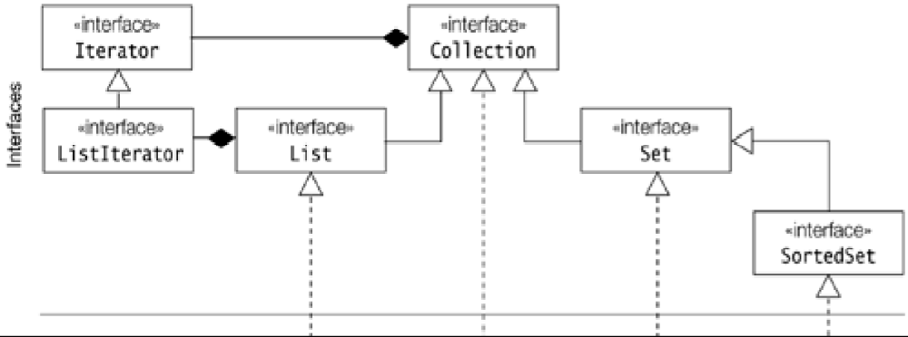
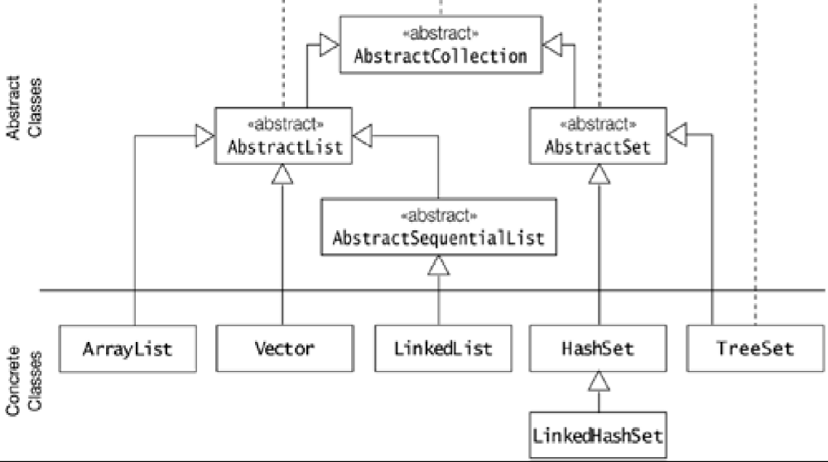

The Core Map Interfaces and Their Implementations

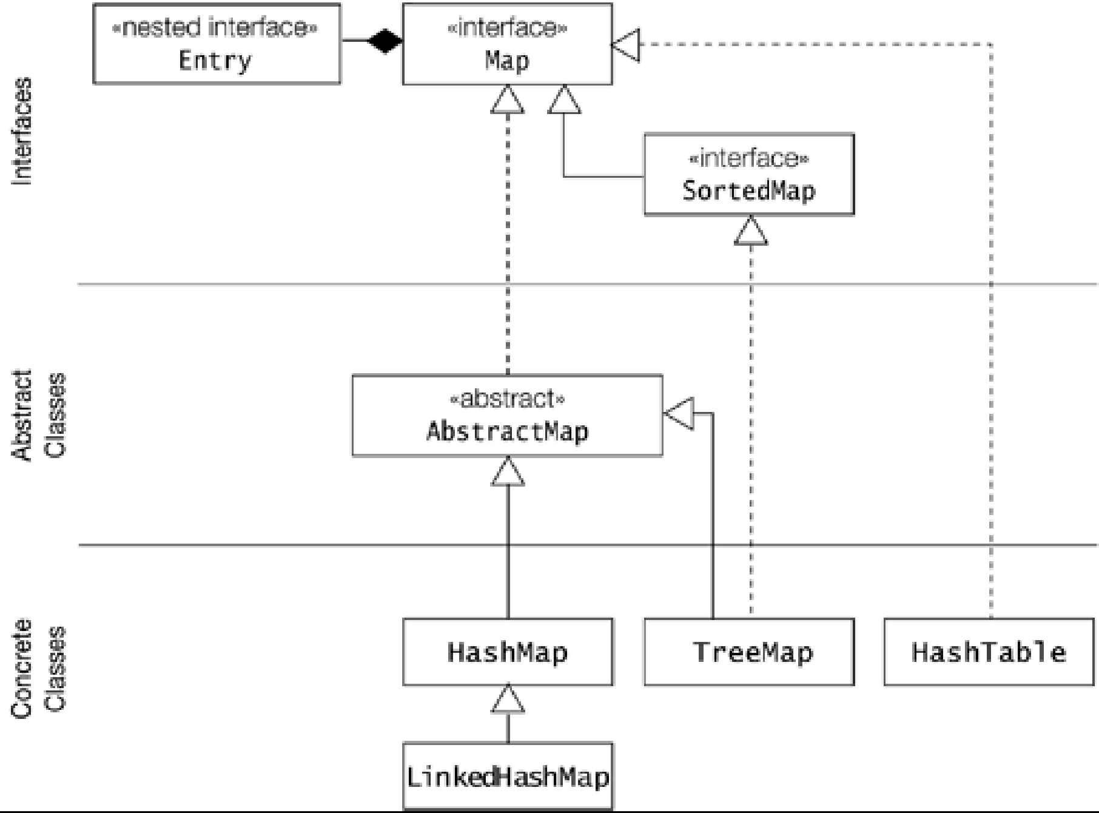

Table: Summary of Collection and Map Implementations

